Use Case - Document

Module Name:Update Details

Use Case Name: Details modification

# ID:104

# Name:Update Details

# Title:

Details modification.

# Description:

Admin has his own dashboard through which he can see the updates of policy holder and agent. Admin can track the activities of agents and policy holder. When admin wants to modify details of agents/policy holder he will change their details.

# Use Case Diagram:

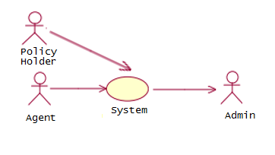

# Pre-Conditions:

1. Admin should be logged in the system.
2. Admin should have his own dashboard.
3. Admin should be able to check the details of agents and policy holder.
4. Admin should be able to change the details of policy holder and agents.

# Post-Conditions:

1. After modification admin should submit the details to save it in database permanently.

# Primary Flow:

1. Admin will log in into the system
2. Admin will check the login credentials about agents and policy holder.
3. If login credentials are correct then admin will make the appropriate changes in the details.
4. After modifying details admin should submit the details to store it permanently in database.

# Data:

1. Agent login credentials
2. Policy holder login credential.
3. Agent and policy holder details available to admin.